Working with NetBeans IDE

Table of Contents:
- Installation of NetBeans IDE ……………………………………………………………………………… 2
- Creating a new project in NetBeans IDE……………………………………………………..6
- Open an existing project into NetBeans IDE…………………………………………………………9
- Execution of scripts in NetBeans IDE …………………………………………………………………..11
- Enabling Terminal in NetBeans IDE……………………………………………………………………….13

Installation of NetBeans IDE:
- Download latest version of NetBeans IDE from the following link.
https://netbeans.org/downloads/

- Click on corresponding download button based on the platform you are working on.

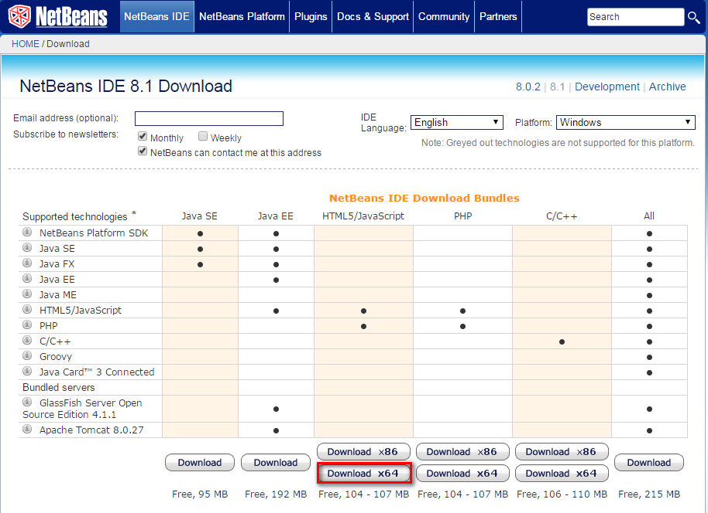

- Click on ‘Run’ button in the following window.

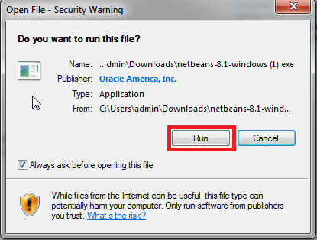

- Click on ‘Next’ in the following window.
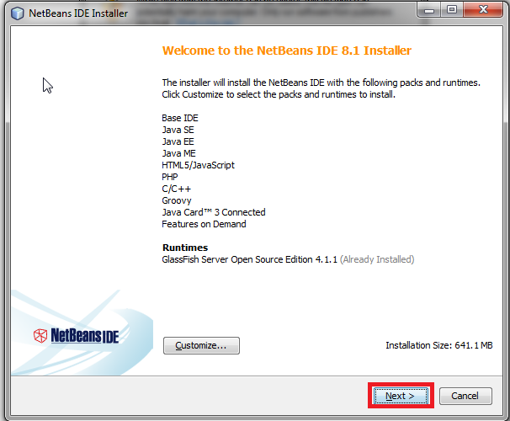
- Accept the license agreement by clicking the check box and click on the ‘Next’ button in the following window.

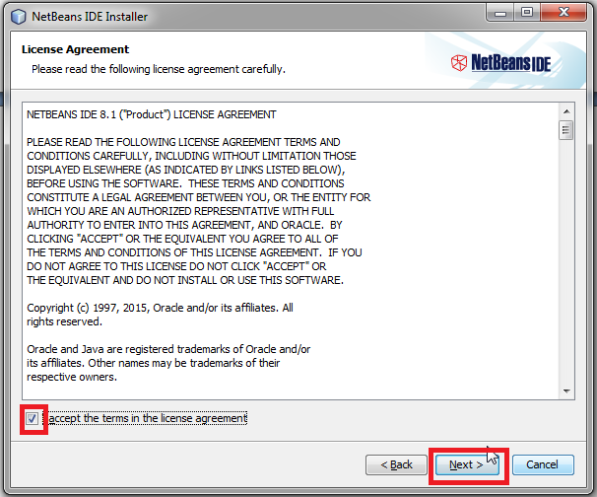

- Specify the location in which the NetBeans IDE is to be installed and also specify the ‘JDK’ path for the NetBeans IDE and click on ‘Next’ button in the following window.

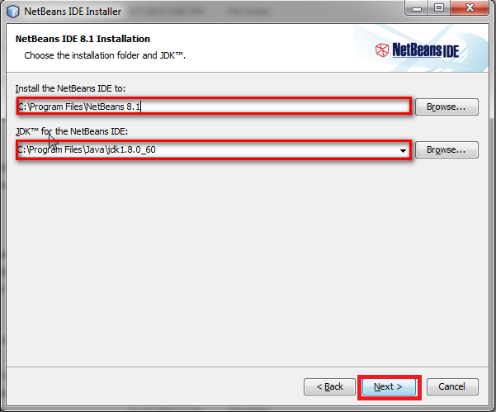
- Click on ‘install’ button in the following window.
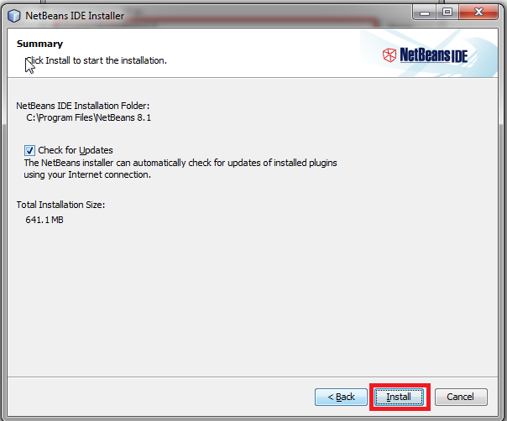
- Once the installation is done click on ‘Finish’ button in the following window.

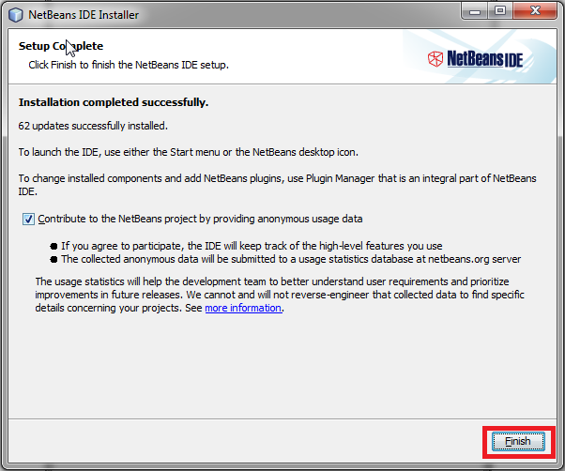

Creating a new project in NetBeans IDE:

- To create a new project in NetBeans IDE ,click on File menu and choose ‘NewProject’.

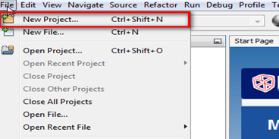

- Choose HTML/Java Script option from the available options as shown in the window and click ‘next’ button.
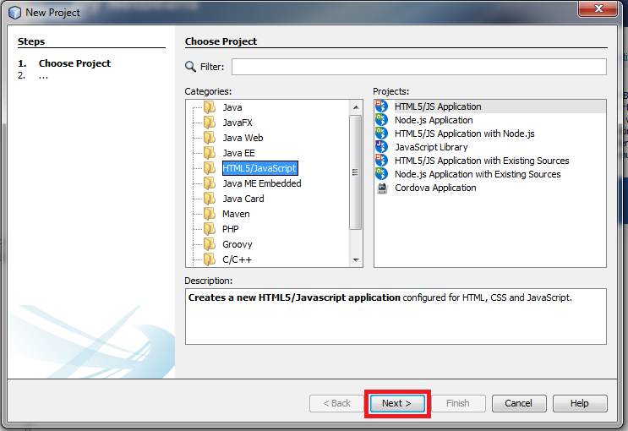

- Specify the project name, project location and project folder as mentioned in the below window and click on ‘next’ button.

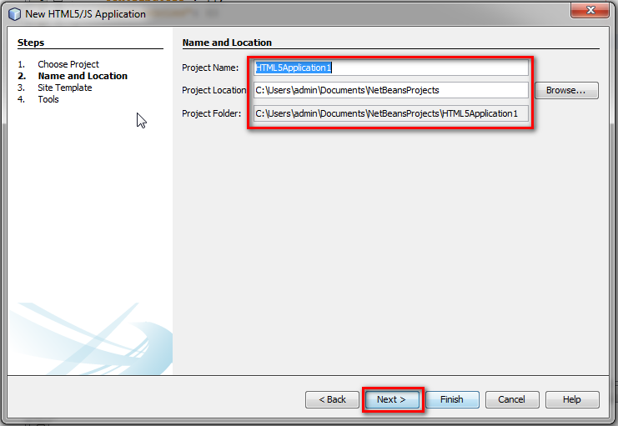

- Select ‘No Site Template’ radio button in the site template window as shown in the below and click ‘next’ button.

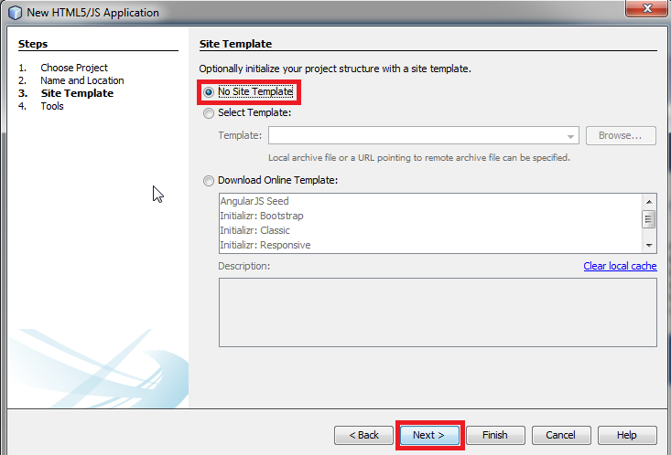

- Choose the tools ‘create package.json’ and ‘create gruntfile.json’ as shown in the below window and click ‘finish’ button.

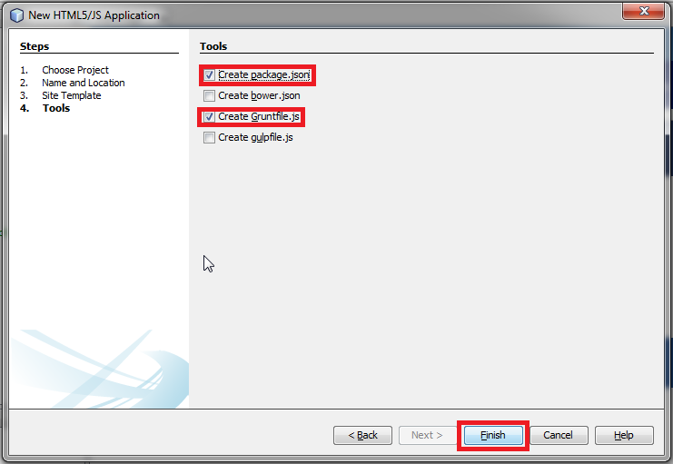

- To create a new .js file right click on ‘Site Root’ mouse hover on ‘new’ and click on ‘JavaScript file’ as shown in the below window.

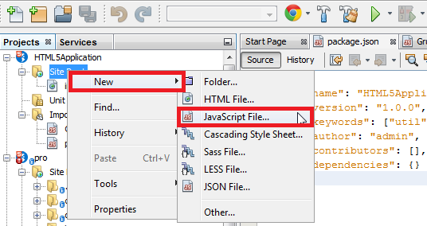
Open an existing project into NetBeans IDE:
- To open an existing project into NetBeans workspace right click on ‘File’ menu and click on ‘Open Project’ as shown in the below window.

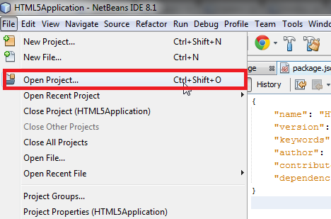

- Choose either of the project from the existing projects and click on ‘Open Project’ button as shown in the below window.
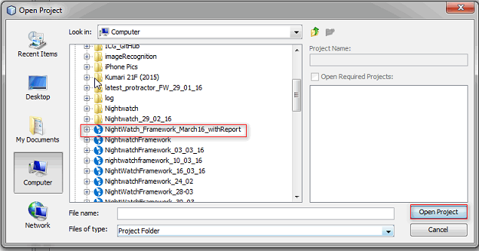

- After successfully importing you can view the folder structure as shown in the below window.

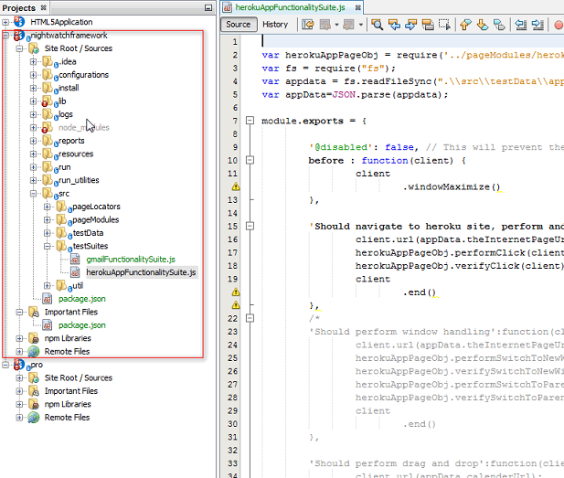

Execution of Scripts:
- To run the scripts, right click on corresponding batch file and click ‘Open in System’ as shown in the below window.

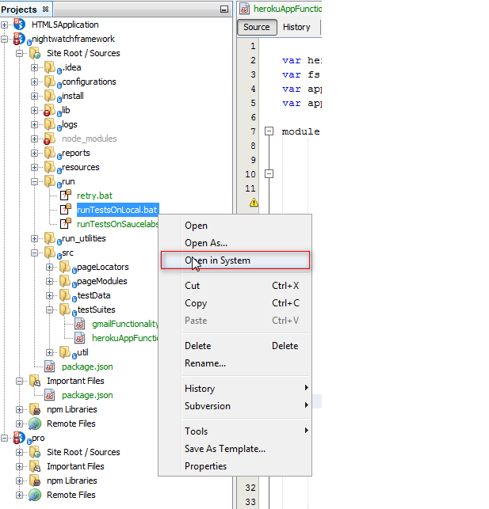

Enabling Terminal in NetBeans IDE

The terminal in the NetBeans IDE will not be enabled directly, to enable that we need to install a ‘Cygwin’ plug-in. The following steps need to be followed in order to make the terminal enable.
- Download the ‘Cygwin’ plug-in from the below link and choose the corresponding .exe file depends upon the OS version.
https://cygwin.com/install.html

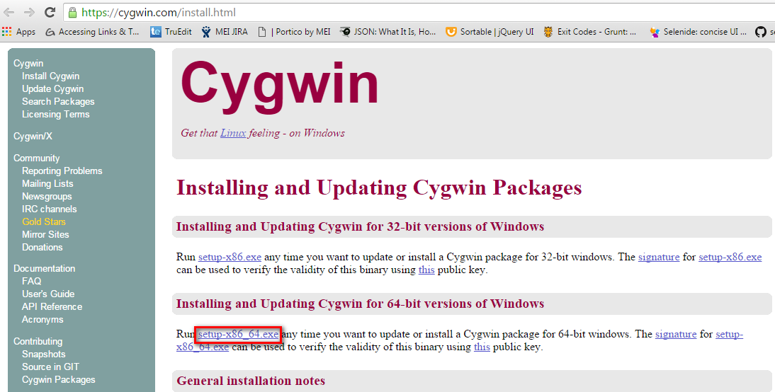

- Once the download is done click on the .exe file and click on ‘Run’ button as shown in the below window.
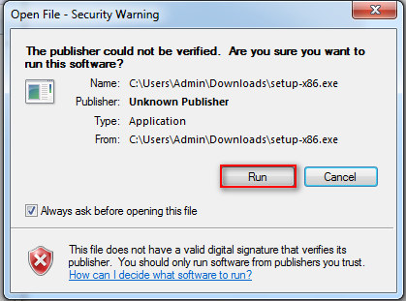
- Click on ‘next’ button as shown in the below window.

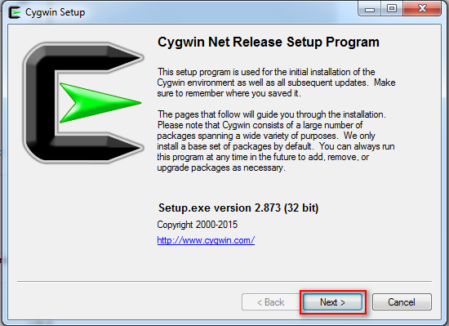

- Click ‘Install from Local History’ radio button to specify the download source and click ‘next’ button as shown in the below window.

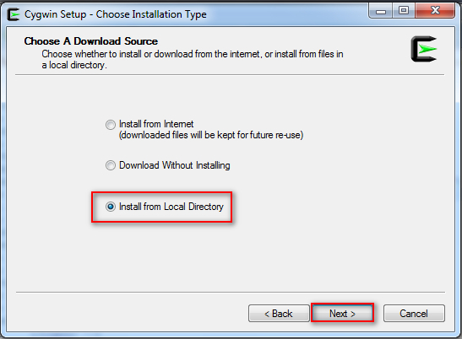

- Specify the location where the downloaded file is available and click ‘next’ button as shown in the below window.

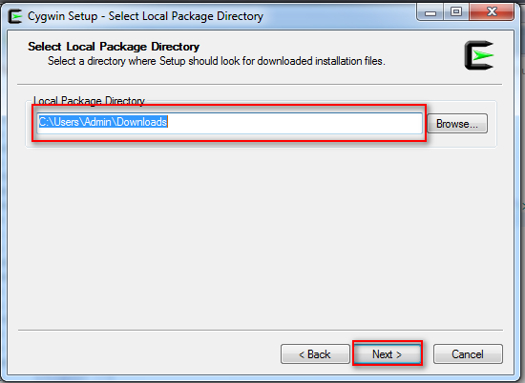

- Specify the location to where the plug-in is to be installed and click on the ‘next’ button as shown in the below window.

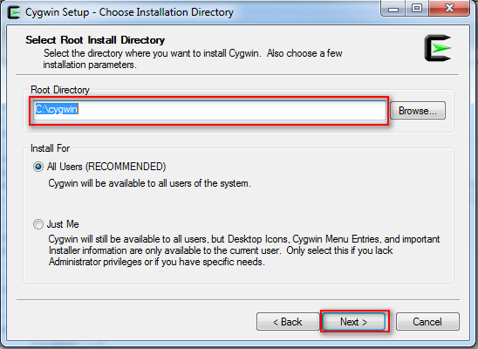
- Click ‘finish’ button as shown in the below window.

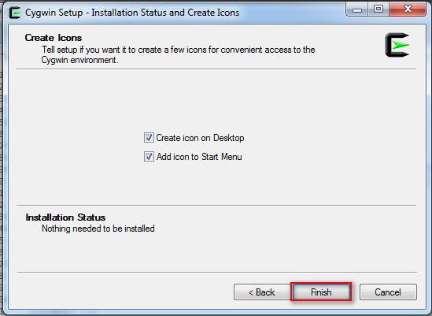

- Open NetBeans IDE and to open the terminal, click ‘Window’ menu and click ‘Terminal’ of ‘IDE Tools’ as shown in the below window.

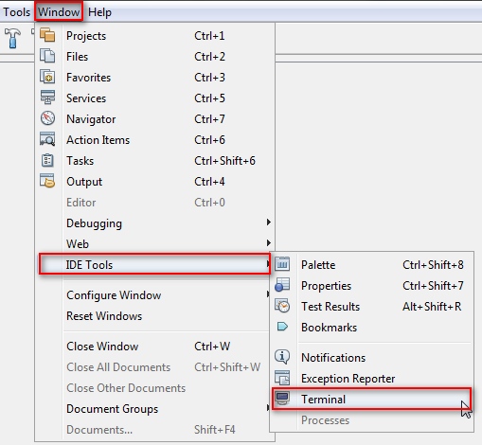
- To work with NetBeans IDE terminal type ‘cmd’ and press ‘Enter ‘ in terminal. After performing this only we will be able to work with terminal otherwise it will show the error command ‘command not found’ as shown in the below window.

